**Content Box**

**Chapter 1: Introduction to HealthPlus**

* **Comprehensive Health Awareness**: HealthPlus educates individuals on health and wellness.
* **Central Hub**: Website offers resources to promote healthy living.
* **Key Sections**: Hero, Services, Health Tips, General Checkup, and Contact.

**Chapter 2: The Hero Section**

* **Attention-Grabbing Design**: Bold graphics and clear messaging.
* **Health Awareness Message**: Emphasizes HealthPlus's mission.
* **Sets Tone**: Establishes the website's focus on accessible health information.

**Chapter 3: Services Offered**

* **Health Screenings**: Early detection of health issues.
* **Educational Workshops**: Topics on nutrition, exercise, mental health.
* **Support Groups and Consultations**: Peer support and personalized health advice.

**Chapter 4: Health Tips**

* **Nutrition and Exercise**: Balanced diet and staying active.
* **Mental Health**: Stress management, sleep improvement.
* **Preventive Care**: Vaccinations, routine checkups, preventive measures.

**Chapter 5: General Checkup Information**

* **Checkup Frequency**: Guidelines for different age groups.
* **Checkup Components**: Typical procedures and tests.
* **Benefits**: Early detection and prevention of health issues.

**Chapter 6: Surveys Conducted in Hospitals**

* **Chronic Diseases Prevalence**: Common conditions affecting patients.
* **Patient Satisfaction**: Quality of care and services feedback.
* **Health Awareness Levels**: Community's understanding of health issues.

**Chapter 7: Contact and Engagement**

* **Contact Form**: Submit questions, feedback, requests.
* **Direct Contact**: Email and phone details.
* **Social Media Links**: Engagement and updates via social profiles.

### Chapter 1: Introduction to HealthPlus

#### **Overview**

HealthPlus is an initiative dedicated to promoting health awareness and education among diverse populations. It aims to bridge the gap between complex medical information and the general public by presenting health topics in an accessible and engaging manner. The core mission of HealthPlus is to empower individuals with the knowledge and tools necessary to lead healthier lives.

#### **Vision and Mission**

**Vision:** To create a well-informed community where every individual has access to accurate health information and resources, enabling them to make informed decisions about their health.

**Mission:** To provide comprehensive health education, promote preventive care, and encourage healthy lifestyle choices through a user-friendly and resource-rich website.

#### **Key Objectives**

1. **Educational Outreach:** To disseminate vital health information through various platforms, ensuring it reaches a broad audience.
2. **Preventive Care Promotion:** To emphasize the importance of preventive measures, such as regular checkups and vaccinations, in maintaining overall health.
3. **Community Engagement:** To actively involve the community through surveys, feedback, and interactive content, ensuring the program meets their needs.
4. **Resource Accessibility:** To provide easy access to a wide range of health resources, including articles, videos, and expert consultations.

#### **Target Audience**

HealthPlus is designed to cater to a diverse audience, including:

* **General Public:** Individuals seeking reliable health information and tips for maintaining a healthy lifestyle.
* **Patients:** People managing chronic conditions or recovering from illnesses, looking for support and guidance.
* **Caregivers:** Family members and friends caring for loved ones, seeking advice on providing the best care.
* **Healthcare Professionals:** Medical practitioners looking for educational resources to recommend to their patients.

#### 

#### **Website Structure**

The HealthPlus website is structured to ensure ease of navigation and access to information. The main sections of the website include:

* **Hero Section:** A visually striking area that highlights the program's key messages and encourages visitors to explore further.
* **Services:** Detailed descriptions of the various health services offered by HealthPlus, including screenings, workshops, and consultations.
* **Health Tips:** A collection of articles and tips on various health topics, updated regularly to reflect the latest research and trends.
* **General Checkup:** Information on the importance of regular health checkups and what to expect during these visits.
* **Contact:** Multiple ways for visitors to get in touch with the HealthPlus team, including a contact form, email, phone, and social media links.

#### **Importance of Health Awareness**

Health awareness is crucial in today's fast-paced world, where misinformation can easily spread. By providing accurate and reliable health information, HealthPlus aims to combat myths and misconceptions, helping individuals make informed decisions about their health. Increased health awareness can lead to:

* **Early Detection:** Recognizing symptoms early and seeking medical attention can prevent complications and improve outcomes.
* **Preventive Measures:** Understanding the importance of vaccinations, screenings, and healthy lifestyle choices can reduce the risk of developing chronic diseases.
* **Empowered Individuals:** Knowledgeable individuals are better equipped to advocate for their health and well-being, leading to improved quality of life.

#### **Conclusion**

HealthPlus is more than just a website; it is a movement towards better health and well-being for all. By focusing on education, preventive care, and community engagement, HealthPlus strives to make a lasting impact on the health of individuals and communities. The initiative's commitment to providing accessible, reliable, and comprehensive health information makes it a valuable resource in the quest for better health.

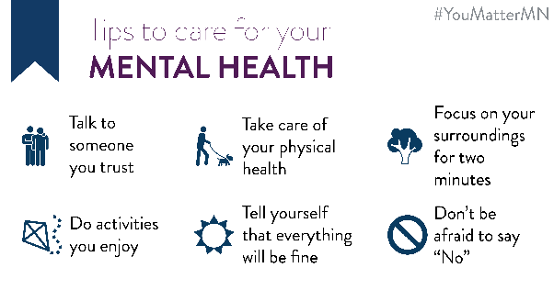

### Chapter 2: The Hero Section

#### **Introduction**

The Hero section is the first thing visitors see when they land on the HealthPlus website. It serves as the gateway to the rest of the site, setting the tone and providing a clear, compelling introduction to the HealthPlus initiative. The design and content of this section are carefully crafted to engage visitors and encourage them to explore further.

#### **Design and Layout**

The Hero section features a clean, modern design with a focus on visual appeal and user experience. Key elements include:

* **Bold Headline:** A powerful, attention-grabbing headline that succinctly communicates the core message of HealthPlus. For example, "Empowering Your Health Journey" or "Your Partner in Health and Wellness."
* **Sub headline:** A brief sub headline that provides additional context or expands on the main headline. This might include a tagline like "Reliable Health Information at Your Fingertips" or "Promoting Preventive Care and Healthy Living."
* **High-Quality Images:** Visually appealing images that reflect the essence of HealthPlus. This could include photos of diverse individuals engaging in healthy activities, images of healthcare professionals, or vibrant illustrations representing health and wellness.
* **Call-to-Action (CTA):** Prominent buttons or links encouraging visitors to take the next step, such as "Learn More," "Explore Our Services," or "Get Health Tips."

#### **Key Features**

1. **Responsive Design:**
   * Ensures that the Hero section looks great and functions well on all devices, including desktops, tablets, and smartphones. This is achieved through adaptive layouts and scalable images.
2. **Intuitive Navigation:**
   * Simplifies the user journey by providing clear pathways to other important sections of the website. For example, navigation links or buttons that direct users to the Services, Health Tips, General Checkup, and Contact sections.
3. **Engaging Visuals:**
   * Utilizes high-resolution images, dynamic backgrounds, or subtle animations to create an engaging and immersive experience. Visuals are chosen to resonate with the target audience and reflect the positive impact of health awareness and education.
4. **Compelling Content:**
   * Includes concise and impactful text that conveys the mission and vision of HealthPlus. The content is crafted to inspire and motivate visitors to take an active role in their health and wellness journey.

#### **Messaging Strategy**

The messaging in the Hero section is designed to be clear, direct, and motivational. It aims to:

* **Introduce HealthPlus:** Provide a brief overview of what HealthPlus is and why it matters. Highlight the program's commitment to health education and preventive care.
* **Build Trust:** Establish credibility by emphasizing the reliability and accuracy of the information provided. Mention any partnerships with healthcare professionals or institutions to bolster trust.
* **Encourage Action:** Prompt visitors to engage with the website through strong CTAs. Whether it's exploring services, reading health tips, or contacting the team, the goal is to guide visitors toward meaningful interactions.

#### **User Engagement**

To maximize user engagement, the Hero section incorporates several interactive elements:

* **Testimonials and Success Stories:**
  + Brief quotes or snippets from individuals who have benefited from HealthPlus services. These testimonials provide social proof and can be linked to more detailed case studies or stories.
* **Highlighting Surveys and Research:**
  + Mention the surveys conducted in hospitals and how the findings contribute to the quality and relevance of the content. This demonstrates a data-driven approach to health education.
* **Quick Access to Resources:**
  + Direct links to popular resources, such as top health tips, upcoming workshops, or recent blog posts. This helps visitors quickly find valuable information without extensive searching.

### 

#### **Conclusion**

The Hero section of the HealthPlus website is a critical component in attracting and retaining visitors. By combining visually appealing design, clear messaging, and interactive elements, it effectively introduces the HealthPlus initiative and encourages visitors to explore the wealth of resources available. This section sets the stage for a positive user experience, ultimately supporting HealthPlus's mission to promote health awareness and education.

### Chapter 3: Services Offered

#### **Introduction**

HealthPlus offers a comprehensive suite of services designed to improve community health and wellness. These services address various aspects of health, from preventive care and early detection to education and support for managing chronic conditions. Each service is tailored to meet the needs of diverse populations, ensuring that everyone has access to the resources they need to lead healthier lives.

#### **Overview of Services**

1. **Health Screenings**
   * **Description:** Regular health screenings are crucial for early detection and prevention of diseases. HealthPlus provides a range of screening services, including blood pressure checks, cholesterol testing, diabetes screenings, and cancer screenings.
   * **Benefits:** Early detection of potential health issues, personalized health advice based on screening results, and improved management of existing conditions.
2. **Educational Workshops**
   * **Description:** HealthPlus organizes educational workshops on various health topics, such as nutrition, physical activity, mental health, and chronic disease management. These workshops are led by healthcare professionals and experts in the field.
   * **Benefits:** Increased knowledge about health and wellness, practical tips for healthy living, and opportunities to ask questions and interact with experts.
3. **Support Groups**
   * **Description:** Support groups provide a safe and supportive environment for individuals dealing with specific health conditions, such as diabetes, cancer, or mental health issues. These groups offer peer support, shared experiences, and professional guidance.
   * **Benefits:** Emotional support, shared coping strategies, and a sense of community and belonging.
4. **Consultations**
   * **Description:** HealthPlus offers one-on-one consultations with healthcare professionals, including doctors, nutritionists, and mental health counselors. These consultations provide personalized advice and support tailored to individual health needs.
   * **Benefits:** Customized health plans, professional guidance, and ongoing support for managing health conditions.

#### **Detailed Descriptions**

**Health Screenings:**

* **Blood Pressure Checks:**
  + **Process:** Quick and painless measurement of blood pressure using a cuff and monitor.
  + **Importance:** High blood pressure is a major risk factor for heart disease and stroke. Regular checks can help manage and control blood pressure levels.
* **Cholesterol Testing:**
  + **Process:** A simple blood test to measure levels of cholesterol in the blood.
  + **Importance:** High cholesterol levels can lead to heart disease. Regular testing helps in managing cholesterol through diet, exercise, and medication if needed.
* **Diabetes Screenings:**
  + **Process:** Blood tests to measure glucose levels, including fasting blood sugar and HbA1c tests.
  + **Importance:** Early detection of diabetes or prediabetes allows for timely intervention and management.
* **Cancer Screenings:**
  + **Process:** Various tests such as mammograms, Pap smears, and colonoscopies to detect different types of cancer.
  + **Importance:** Early detection significantly improves treatment outcomes and survival rates.

# **Educational Workshops:**

* **Nutrition:**
  + **Topics Covered:** Balanced diet, meal planning, reading food labels, and understanding nutrients.
  + **Benefits:** Better dietary choices, improved overall health, and prevention of diet-related diseases.
* **Physical Activity:**
  + **Topics Covered:** Benefits of regular exercise, types of exercises, creating a workout routine, and staying motivated.
  + **Benefits:** Enhanced physical fitness, weight management, and reduced risk of chronic diseases.
* **Mental Health:**
  + **Topics Covered:** Stress management, improving sleep, coping with anxiety and depression, and building resilience.
  + **Benefits:** Improved mental well-being, better stress management, and a positive outlook on life.
* **Chronic Disease Management:**
  + **Topics Covered:** Managing conditions like diabetes, hypertension, and asthma, medication adherence, and lifestyle modifications.
  + **Benefits:** Better control of chronic conditions, reduced complications, and improved quality of life.

# **Support Groups:**

* **Diabetes Support Group:**
  + **Activities:** Sharing experiences, discussing challenges, and learning from others.
  + **Benefits:** Emotional support, practical advice, and improved diabetes management.
* **Cancer Support Group:**
  + **Activities:** Coping strategies, survivor stories, and professional guidance.
  + **Benefits:** Enhanced emotional well-being, shared experiences, and support through treatment and recovery.
* **Mental Health Support Group:**
  + **Activities:** Group discussions, mindfulness exercises, and therapeutic activities.
  + **Benefits:** Reduced feelings of isolation, improved coping mechanisms, and peer support.

# **Consultations:**

* **Doctor Consultations:**
  + **Services:** General health check-ups, diagnosis, treatment plans, and follow-up care.
  + **Benefits:** Personalized medical advice, early detection of health issues, and comprehensive care.
* **Nutritionist Consultations:**
  + **Services:** Dietary assessments, meal planning, and nutrition counseling.
  + **Benefits:** Customized nutrition plans, weight management, and improved dietary habits.
* **Mental Health Counselor Consultations:**
  + **Services:** Counseling sessions, stress management techniques, and mental health assessments.
  + **Benefits:** Improved mental health, coping strategies, and emotional support.

#### **Conclusion**

HealthPlus's array of services is designed to cater to the diverse needs of the community. By offering health screenings, educational workshops, support groups, and personalized consultations, HealthPlus empowers individuals to take charge of their health and well-being. These services not only provide immediate benefits but also foster long-term health improvements, contributing to a healthier and more informed community

### Chapter 4: Health Tips

#### **Introduction**

The Health Tips section is a cornerstone of the HealthPlus website, providing visitors with practical advice and insights on maintaining and improving their health. This section is designed to be user-friendly and accessible, offering a wide range of tips that cover various aspects of health and wellness. The goal is to empower individuals with the knowledge they need to make informed health decisions and adopt healthier lifestyles.

#### **Content Organization**

The Health Tips section is organized into several categories, each focusing on a specific area of health. This structured approach ensures that users can easily find the information they are looking for. The main categories include:

1. **Nutrition**
2. **Exercise**
3. **Mental Health**
4. **Preventive Care**
5. **Lifestyle Choices**

#### **Nutrition**

**Overview:** The nutrition category provides tips and advice on maintaining a balanced diet and making healthy food choices. It emphasizes the importance of proper nutrition in overall health and well-being.

**Key Topics:**

* **Balanced Diet:** Information on the components of a balanced diet, including macronutrients (carbohydrates, proteins, fats) and micronutrients (vitamins, minerals).
* **Healthy Eating Habits:** Tips on portion control, meal planning, and mindful eating.
* **Superfoods:** Highlighting nutrient-dense foods that provide significant health benefits.
* **Dietary Restrictions:** Advice for individuals with specific dietary needs, such as gluten-free, vegetarian, or vegan diets.

**Example Tips:**

* "Incorporate a variety of fruits and vegetables into your meals to ensure you get a range of essential nutrients."
* "Stay hydrated by drinking plenty of water throughout the day, aiming for at least 8 glasses."

#### **Exercise**

**Overview:** The exercise category offers guidance on incorporating physical activity into daily routines, emphasizing the importance of regular exercise for maintaining physical and mental health.

**Key Topics:**

* **Types of Exercise:** Information on different forms of exercise, including aerobic, strength training, flexibility, and balance exercises.
* **Exercise Routines:** Sample workout routines for beginners, intermediates, and advanced fitness levels.
* **Exercise Benefits:** Detailed explanations of the physical and mental health benefits of regular exercise.
* **Staying Motivated:** Tips on setting realistic fitness goals and staying motivated to maintain an exercise regimen.

**Example Tips:**

* "Aim for at least 150 minutes of moderate-intensity aerobic activity each week, such as brisk walking or cycling."
* "Incorporate strength training exercises at least two days a week to build muscle and improve bone density."

#### **Mental Health**

**Overview:** The mental health category addresses the importance of mental well-being and provides strategies for managing stress, improving sleep, and maintaining a positive mindset.

**Key Topics:**

* **Stress Management:** Techniques for managing stress, including mindfulness, meditation, and relaxation exercises.
* **Sleep Hygiene:** Tips for improving sleep quality and establishing a healthy sleep routine.
* **Mental Wellness:** Advice on maintaining a positive outlook, building resilience, and seeking support when needed.
* **Mental Health Resources:** Information on where to find professional help for mental health issues.

**Example Tips:**

* "Practice mindfulness meditation for a few minutes each day to reduce stress and enhance emotional well-being."
* "Establish a regular sleep schedule by going to bed and waking up at the same time each day, even on weekends."

#### **Preventive Care**

**Overview:** The preventive care category emphasizes the importance of proactive health measures to prevent illness and maintain optimal health.

**Key Topics:**

* **Vaccinations:** Information on recommended vaccinations for different age groups and their importance.
* **Regular Checkups:** Advice on the frequency and types of health checkups needed for various life stages.
* **Screenings:** Details on important health screenings, such as blood pressure, cholesterol, and cancer screenings.
* **Healthy Habits:** Tips on maintaining a smoke-free lifestyle, moderating alcohol consumption, and practicing safe behaviors.

**Example Tips:**

* "Schedule regular health checkups with your primary care physician to monitor your health and catch potential issues early."
* "Stay up-to-date with recommended vaccinations to protect yourself and others from preventable diseases."

#### **Lifestyle Choices**

**Overview:** The lifestyle choices category offers guidance on making everyday decisions that contribute to overall health and well-being.

**Key Topics:**

* **Healthy Relationships:** Tips for building and maintaining healthy, supportive relationships.
* **Work-Life Balance:** Strategies for balancing professional and personal life to reduce stress and improve quality of life.
* **Hygiene Practices:** Advice on personal hygiene practices to prevent illness and maintain health.
* **Environmental Health:** Information on how to create a healthy living environment, including tips on reducing exposure to pollutants and toxins.

**Example Tips:**

* "Maintain strong social connections by spending time with family and friends, and seeking support when needed."
* "Create a work-life balance by setting boundaries, prioritizing self-care, and taking time to relax and recharge."

#### **Interactive Elements**

To enhance user engagement, the Health Tips section includes various interactive elements:

* **Quizzes and Assessments:** Short quizzes to help users assess their health habits and identify areas for improvement.
* **Infographics and Videos:** Visually engaging content to explain complex health topics in an easy-to-understand format.
* **Downloadable Resources:** Printable guides, checklists, and planners to help users implement health tips in their daily lives.
* **User Contributions:** A space for users to share their own health tips and success stories, fostering a sense of community.

#### 

#### **Conclusion**

The Health Tips section of HealthPlus is a valuable resource for anyone looking to improve their health and well-being. By providing practical, evidence-based advice across various health topics, this section empowers users to take charge of their health. The combination of clear, concise information and engaging interactive elements ensures that visitors can easily find and apply the tips that are most relevant to their lives.

### Chapter 5: General Checkup Information

#### **Importance of Regular Checkups**

Regular health checkups are fundamental to maintaining good health and early detection of potential health issues. They serve as a preventive measure, helping individuals monitor their health status and take proactive steps to address any emerging concerns. HealthPlus emphasizes the significance of these checkups through the General Checkup section on the website, providing visitors with comprehensive information and guidance.

#### **Frequency of Checkups**

HealthPlus provides clear guidelines on how often different age groups and individuals with specific health conditions should have checkups:

* **Children:** Regular checkups are crucial during childhood to monitor growth and development, administer vaccinations, and address any health issues early.
  + **Infants (0-1 year):** Monthly visits for the first six months, then every two to three months.
  + **Toddlers (1-3 years):** Every six months.
  + **Children (3-18 years):** Annually.
* **Adults:** Regular checkups help maintain overall health, detect chronic conditions early, and manage risk factors.
  + **Young Adults (18-39 years):** Every 2-3 years.
  + **Middle-aged Adults (40-64 years):** Every 1-2 years.
  + **Seniors (65+ years):** Annually.

# **Components of a Checkup**

A typical general checkup includes various assessments and tests to evaluate an individual’s overall health:

* **Medical History:** Discussion of personal and family medical history, lifestyle factors, and any current health concerns.
* **Vital Signs:** Measurement of blood pressure, heart rate, respiration rate, and temperature.
* **Physical Examination:** Thorough examination of the body, including the heart, lungs, abdomen, and neurological functions.
* **Laboratory Tests:** Blood tests, urine tests, and other diagnostic tests to screen for common conditions such as diabetes, high cholesterol, and kidney function.
* **Preventive Screenings:** Depending on age and risk factors, screenings for cancer (e.g., mammograms, Pap smears, colonoscopies), bone density, and other conditions.
* **Vaccinations:** Administration of necessary vaccines or boosters to prevent infectious diseases.
* **Health Counseling:** Advice on maintaining a healthy lifestyle, including diet, exercise, stress management, and smoking cessation.

#### **Benefits of Regular Checkups**

HealthPlus highlights the numerous benefits of regular health checkups, emphasizing how they contribute to long-term well-being:

* **Early Detection and Treatment:** Identifying health issues early, when they are most treatable, can prevent complications and improve outcomes.
* **Disease Prevention:** Regular checkups include preventive measures such as vaccinations and lifestyle counseling, reducing the risk of developing chronic conditions.
* **Health Monitoring:** Keeping track of vital health indicators helps in managing existing conditions and adjusting treatments as needed.
* **Personalized Care:** Building a relationship with healthcare providers allows for personalized advice and tailored health plans.
* **Peace of Mind:** Regular checkups provide reassurance and reduce anxiety about potential health problems.

#### **Encouraging Regular Checkups**

HealthPlus uses various strategies to encourage visitors to prioritize regular checkups:

* **Educational Content:** Articles and videos explaining the importance of checkups, what to expect during a visit, and how to prepare.
* **Reminders and Alerts:** Tools for setting reminders for upcoming checkups and screenings.
* **Testimonials:** Stories from individuals who benefited from early detection and preventive care, reinforcing the value of regular checkups.
* **Resources:** Links to find local healthcare providers, schedule appointments, and access support services.

#### **Addressing Common Concerns**

The General Checkup section also addresses common concerns and misconceptions about health checkups:

* **Cost and Insurance:** Information on how to navigate insurance coverage for checkups and potential costs.
* **Time Constraints:** Tips for scheduling appointments that fit into busy lifestyles and making the most of each visit.
* **Fear and Anxiety:** Strategies for overcoming fear of doctors or medical procedures, including bringing a friend or family member for support and discussing concerns with healthcare providers.

#### **Conclusion**

The General Checkup section of the HealthPlus website is designed to empower individuals with the knowledge and resources they need to prioritize regular health checkups. By providing detailed information on the importance, frequency, and components of checkups, HealthPlus aims to encourage proactive health management and support overall well-being. Regular checkups are a key element of preventive care, and HealthPlus is committed to helping individuals understand and embrace this essential aspect of health maintenance.

### 

### Chapter 6: Surveys Conducted in Hospitals

#### **Introduction**

Surveys conducted in hospitals are a cornerstone of the HealthPlus program, providing critical insights into the health needs and concerns of the community. These surveys inform the development of HealthPlus's resources and services, ensuring they are relevant, effective, and tailored to the audience's needs. This chapter delves into the methodology, findings, and implications of these surveys.

#### **Survey Methodology**

To ensure comprehensive and accurate data collection, HealthPlus employed a structured survey methodology:

1. **Target Population:**
   * Patients, caregivers, and healthcare professionals in hospitals across various regions. This diverse sample helps capture a wide range of perspectives and experiences.
2. **Survey Design:**
   * Questions were designed to be clear, concise, and relevant. They covered topics such as common health concerns, patient satisfaction, awareness of preventive measures, and the effectiveness of existing health interventions.
3. **Data Collection:**
   * Surveys were distributed both digitally and physically. Digital surveys were sent via email and social media platforms, while physical surveys were available in hospital waiting areas and during health checkup events.
4. **Data Analysis:**
   * Collected data was analyzed using statistical software to identify trends, correlations, and significant findings. The analysis focused on understanding common health issues, the level of health awareness, and areas needing improvement.

#### **Key Findings**

The surveys yielded valuable insights into several critical areas:

1. **Prevalence of Chronic Diseases:**
   * High rates of chronic conditions such as diabetes, hypertension, and cardiovascular diseases were observed. This highlights the need for targeted education and intervention programs to manage and prevent these conditions.
2. **Patient Satisfaction:**
   * Feedback on hospital experiences revealed varying levels of satisfaction with healthcare services. Common concerns included long wait times, communication gaps between patients and healthcare providers, and the need for more personalized care.
3. **Health Awareness Levels:**
   * A significant portion of the population demonstrated a lack of awareness about preventive health measures, such as regular screenings and vaccinations. This underscores the importance of HealthPlus's educational efforts.
4. **Barriers to Healthcare:**
   * Identified barriers included financial constraints, lack of transportation, and limited access to healthcare facilities. These barriers prevent many individuals from seeking timely medical care and highlight areas where HealthPlus can intervene.

#### **Impact on HealthPlus Programs**

The survey findings have had a profound impact on shaping the HealthPlus initiative:

1. **Tailored Health Education:**
   * Based on the high prevalence of chronic diseases, HealthPlus has developed targeted educational content and workshops focusing on the management and prevention of these conditions. This includes resources on diet, exercise, medication adherence, and lifestyle changes.
2. **Improved Patient Communication:**
   * Addressing communication gaps, HealthPlus introduced tools and training programs for healthcare providers to enhance patient interactions. This includes developing clear, patient-friendly materials and training sessions on effective communication skills.
3. **Enhanced Preventive Care Campaigns:**
   * To address low awareness levels, HealthPlus launched comprehensive preventive care campaigns. These campaigns promote the importance of regular health checkups, vaccinations, and screenings, using a variety of channels such as social media, community events, and partnerships with local organizations.
4. **Accessibility Initiatives:**
   * Recognizing the barriers to healthcare, HealthPlus has implemented programs to improve accessibility. This includes organizing mobile health clinics, providing transportation services, and offering financial.

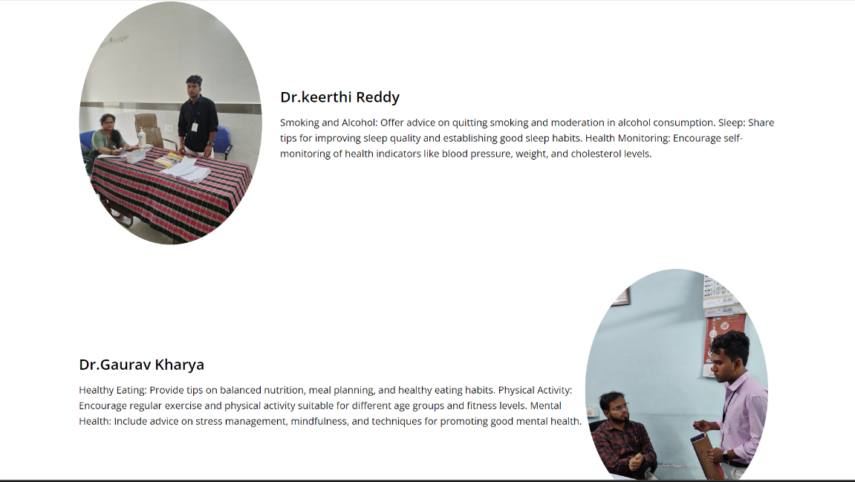

# **Community Engagement**

HealthPlus actively involves the community in its programs:

1. **Feedback Loops:**
   * Continuous feedback from the community is encouraged to refine and improve HealthPlus services. This includes regular follow-up surveys and community meetings to discuss health concerns and suggestions.
2. **Collaborations with Hospitals:**
   * HealthPlus collaborates closely with hospitals to ensure that the programs align with the needs of both patients and healthcare providers. These partnerships facilitate the sharing of resources and expertise.
3. **Volunteer Programs:**
   * Volunteer programs are established to engage community members in HealthPlus activities. Volunteers help with data collection, outreach efforts, and organizing health

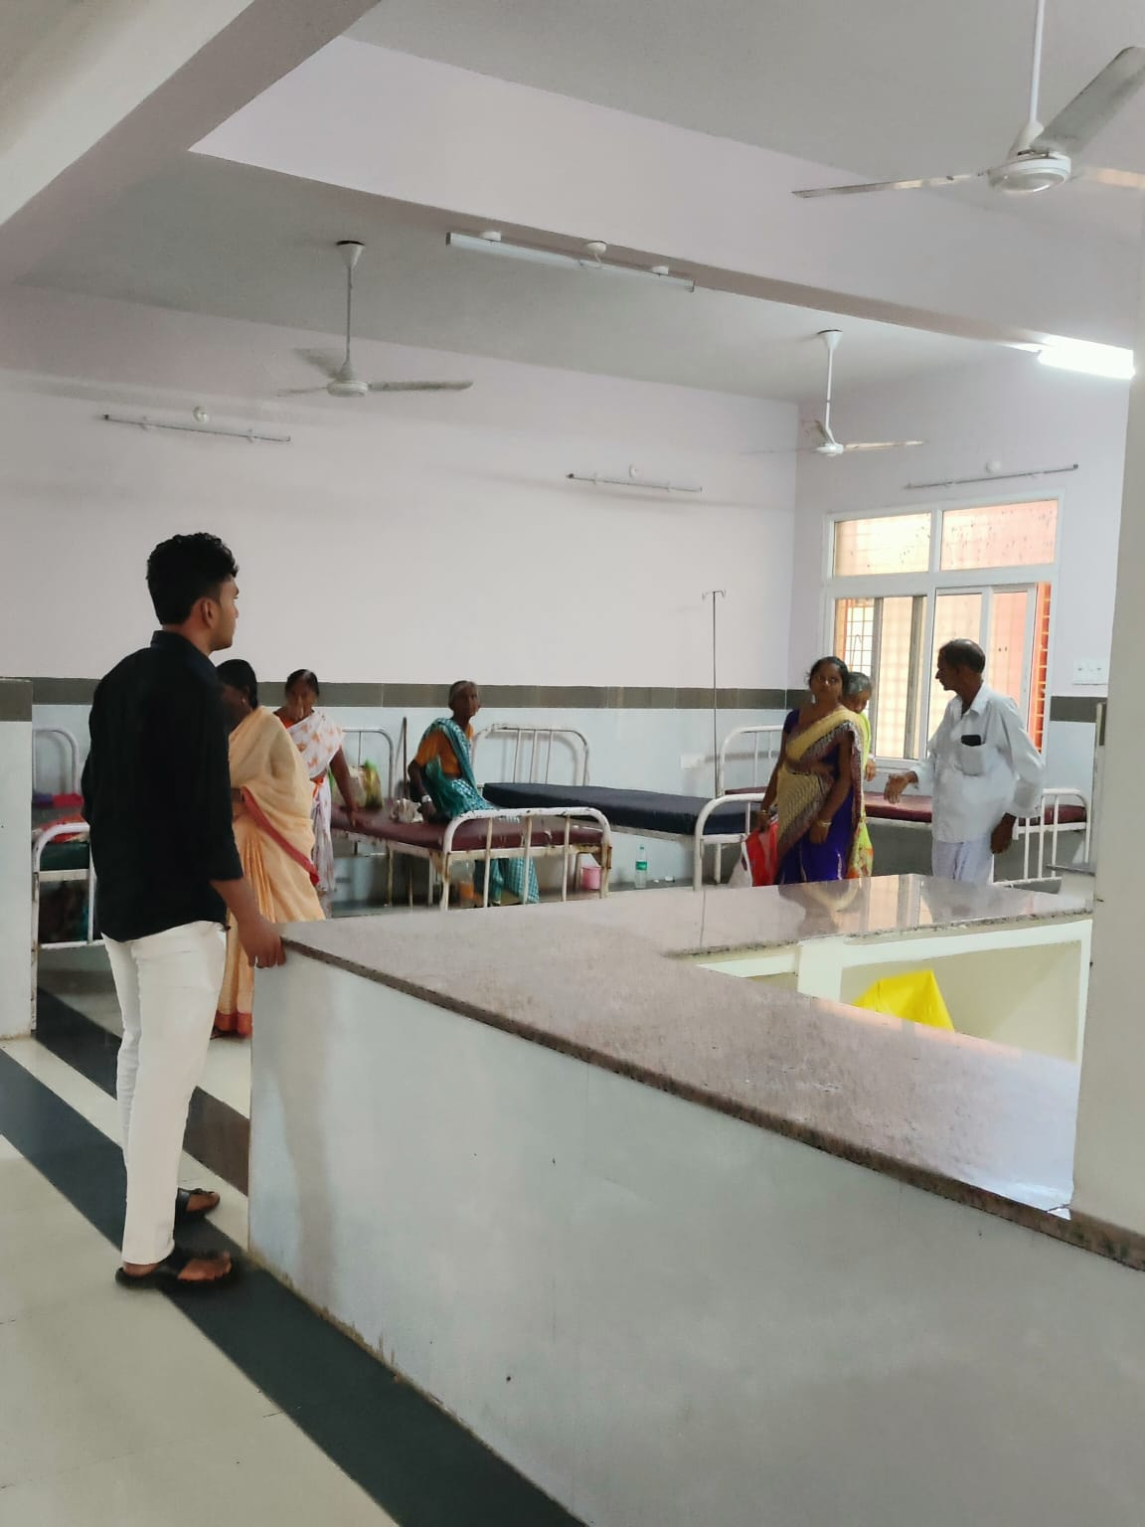

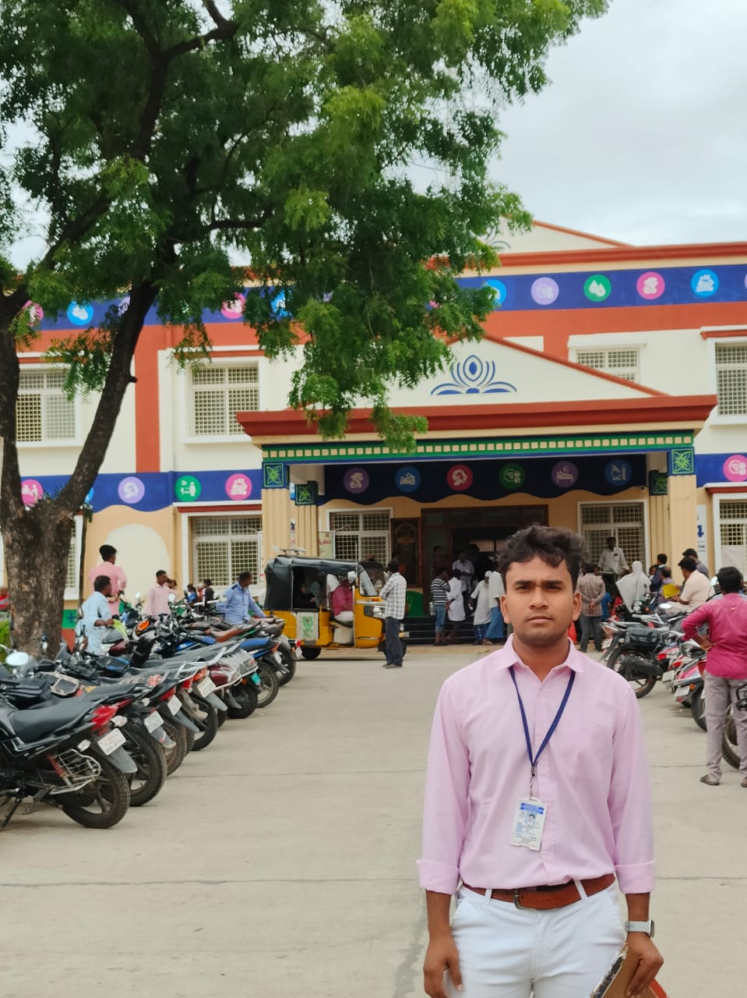

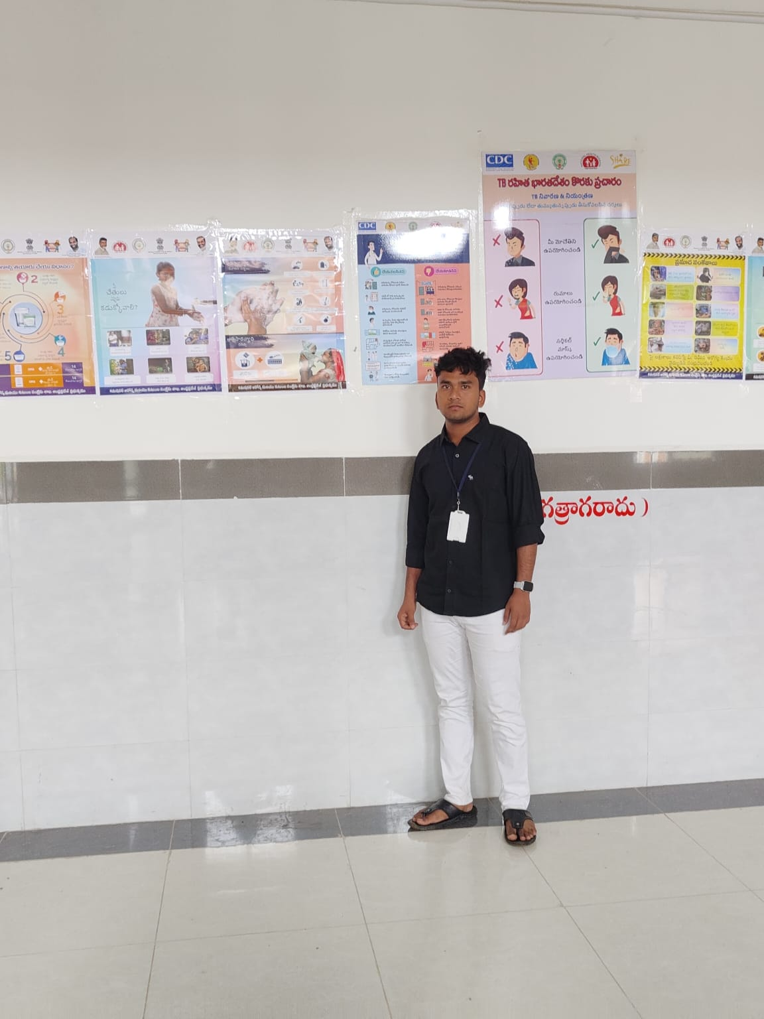

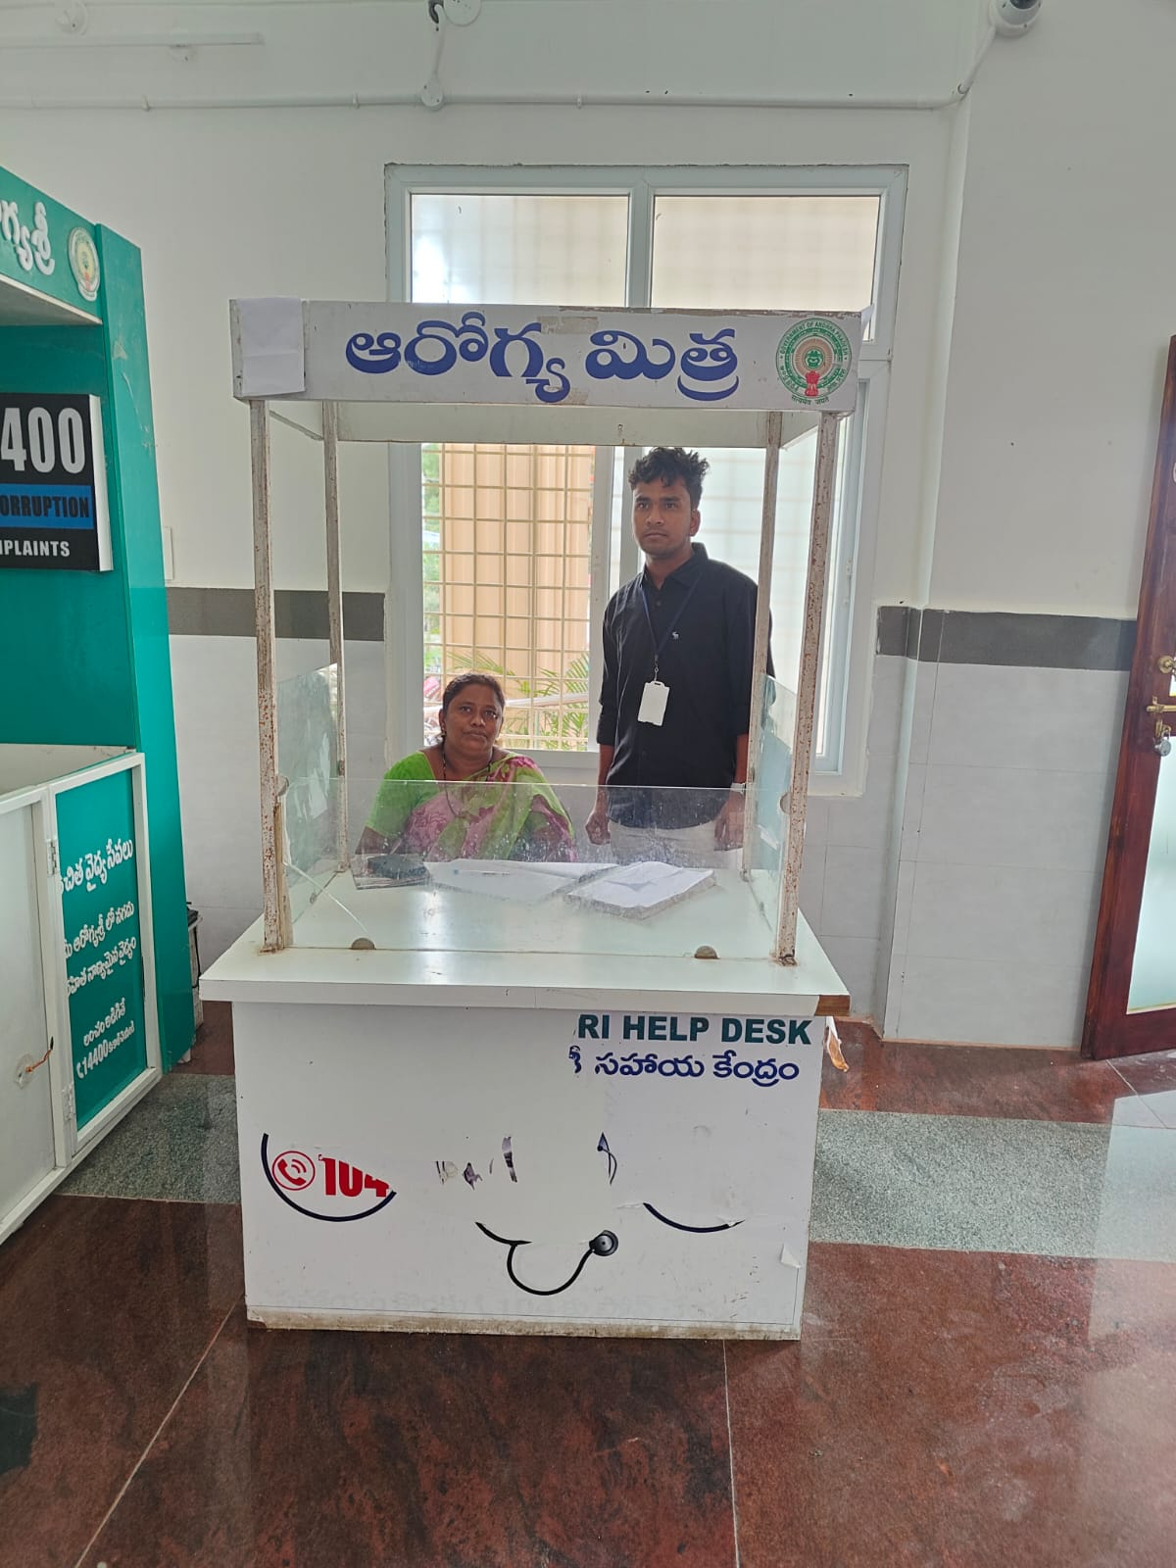

.

#### **Future Directions**

The insights gained from hospital surveys guide the future direction of HealthPlus:

1. **Expanding Survey Reach:**
   * HealthPlus plans to extend its surveys to more hospitals and healthcare facilities, including rural and underserved areas, to gather a broader range of data and address diverse health needs.
2. **Advanced Data Analytics:**
   * Investing in advanced data analytics tools to gain deeper insights from survey data. This includes predictive analytics to identify emerging health trends and proactive measures to address them.
3. **Continuous Improvement:**
   * Committed to a cycle of continuous improvement, HealthPlus will regularly update its programs based on new survey data, ensuring they remain relevant and effective in addressing community health needs.

#### **Conclusion**

The surveys conducted in hospitals are a vital component of the HealthPlus program, providing the data-driven foundation for its initiatives. By understanding the health concerns and needs of the community, HealthPlus can develop and refine its services to have a meaningful impact. The ongoing engagement with the community and healthcare providers ensures that HealthPlus remains a responsive and effective health awareness program.

### Chapter 7: Contact and Engagement

#### **Introduction**

The Contact and Engagement section of the HealthPlus website is a crucial component, designed to facilitate communication between visitors and the HealthPlus team. This section ensures that users can easily reach out for support, provide feedback, ask questions, and engage with the HealthPlus community. Effective contact and engagement strategies enhance user satisfaction and foster a sense of community and trust.

#### **Contact Options**

1. **Contact Form:**
   * **Purpose:** The contact form allows visitors to send messages directly through the website. It’s a straightforward way for users to ask questions, provide feedback, or request more information.
   * **Features:**
     + Fields for name, email, subject, and message.
     + Option to select the type of inquiry (e.g., general question, feedback, service inquiry).
     + CAPTCHA or other security measures to prevent spam.
2. **Email:**
   * **Purpose:** Email contact provides a direct line of communication for more detailed or specific inquiries.
   * **Features:**
     + A dedicated email address (e.g., info@healthplus.org) displayed prominently on the Contact page.
3. **Phone:**
   * **Purpose:** Phone contact offers immediate support for urgent inquiries or those who prefer verbal communication.
   * **Features:**
     + A dedicated phone number for customer support or inquiries.
     + Hours of availability clearly listed.
4. **Social Media Links:**
   * **Purpose:** Social media platforms extend engagement beyond the website, allowing for real-time interactions and updates.
   * **Features:**
     + Links to HealthPlus profiles on popular social media platforms such as Facebook, Twitter, Instagram, and LinkedIn.
     + Icons are prominently displayed and easily accessible.
5. **Live Chat:**
   * **Purpose:** Live chat provides instant support for visitors who have immediate questions or need help navigating the site.
   * **Features:**
     + A chat widget accessible from any page of the website.
     + Trained support agents or automated responses for common queries.

#### **Community Engagement**

1. **Newsletter Subscription:**
   * **Purpose:** Keep users informed about the latest news, health tips, upcoming events, and new services.
   * **Features:**
     + Simple subscription form requiring only an email address.
     + Option to customize preferences for the type of content received.
2. **Feedback and Surveys:**
   * **Purpose:** Gather user feedback to improve services and content.
   * **Features:**
     + Regular surveys and feedback forms.
     + Incentives such as discounts or free resources for participation.
3. **Events and Webinars:**
   * **Purpose:** Engage with the community through interactive and educational events.
   * **Features:**
     + Calendar of upcoming events and webinars.
     + Easy registration process and reminders.
4. **Blogs and Articles:**
   * **Purpose:** Provide in-depth information on health topics and engage users through valuable content.
   * **Features:**
     + Regularly updated blog with articles written by health experts.
     + Comment sections for user interaction and discussion.
5. **Online Forums:**
   * **Purpose:** Create a space for users to share experiences, ask questions, and support each other.
   * **Features:**
     + Moderated forums organized by health topics.
     + User profiles and direct messaging capabilities.

#### **Engaging Content and Resources**

1. **Resource Library:**
   * **Purpose:** Offer a comprehensive library of health-related resources.
   * **Features:**
     + Downloadable guides, e-books, and brochures.
     + Searchable database for easy access to information.
2. **Video Tutorials and Webinars:**
   * **Purpose:** Provide visual and interactive content to enhance learning.
   * **Features:**
     + Library of recorded webinars and tutorials.
     + Live Q&A sessions with health professionals.
3. **Case Studies and Success Stories:**
   * **Purpose:** Showcase real-life examples of how HealthPlus has made a difference.
   * **Features:**
     + Detailed case studies and testimonials.
     + Impact stories highlighting the benefits of HealthPlus services.

#### **Analytics and Improvement**

1. **Tracking and Analysis:**
   * **Purpose:** Monitor user interactions and engagement to continuously improve the website and services.
   * **Features:**
     + Analytics tools to track page views, user behavior, and engagement metrics.
     + Regular reports and insights to inform decision-making.
2. **User Feedback Integration:**
   * **Purpose:** Incorporate user feedback into ongoing improvements and new features.
   * **Features:**
     + Feedback loops to ensure user suggestions are considered.
     + Regular updates and enhancements based on user input.

#### 

#### **Conclusion**

The Contact and Engagement section of the HealthPlus website is designed to foster open communication and build a strong community around health awareness. By providing multiple channels for contact, engaging users with valuable content, and continuously improving based on feedback, HealthPlus ensures that visitors feel supported and empowered in their health journeys. This section not only facilitates effective communication but also strengthens the overall mission of HealthPlus to promote health and wellness in the community.

Top of Form

Bottom of Form